
COMSATS UNIVERSITY, ISLAMABAD
Department of Computer Science
Assignment - 1, Fall - 2025

Course: Artificial Intelligence (CSC462) Class: BSE- 3rd
Instructor: Waqas Ali Total Marks: 10
CLO-2: Apply various AI problem solving and searching techniques to a real-world problem

Q1 Consider that a person has never been to the city air port. Its early in the morning and assume that no other person is awake in the town who can guide him on the way. He has to drive on his car but doesn’t know the way to airport. Clearly identify the four components of problem solving in the above statement, i.e. problem statement, operators, solution space, and goal state. Should he follow blind or heuristic search strategy? Try to model the problem in a graphical representation.

Q2 Clearly identify the difference between WSP (Well-Structured Problems) and ISP (Ill- Structured) problems as discussed in the lecture. Give relevant examples.

Q3 Given the following tree. Apply DFS and BFS as studied in the chapter. Show the state of the data structure Q and the visited list clearly at every step. S is the initial state and D is the goal state.
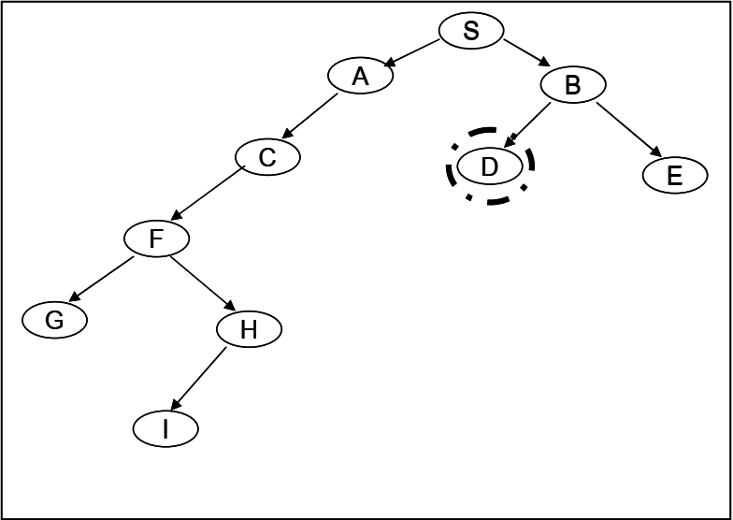
Q4 Discuss how progressive deepening uses a mixture of DFS and BFS to eliminate the disadvantages of both and at the same time finds the solution is a given tree. Support your answer with examples of a few trees.

Q5 Discuss the problems in Hill Climbing. Suggest solutions to the commonly encountered problems that are local maxima, plateau problem and ridge problem. Given the following tree, use the hill climbing procedure to climb up the tree. Use your suggested solutions to the above mention problems if any of them are encountered. K is the goal state and numbers written on each node is the estimate of remaining distance to the goal.
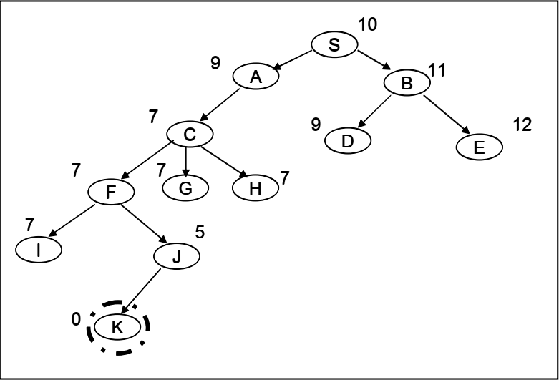

Q6 Discuss how best first search works in a tree. Support your answer with an example tree. Is best first search always the best strategy? Will it always guarantee the best solution?

Q7 Discuss how beam search with degree of the search = 3 propagates in the given search tree. Is it equal to best first search when the degree = 1.
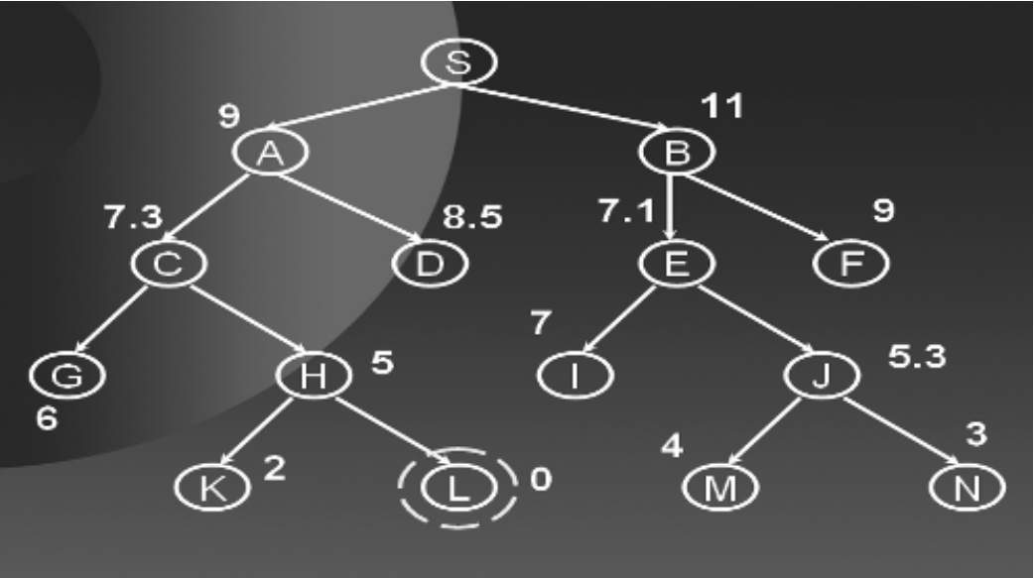
Q8 Discuss the main concept behind branch and bound search strategy. Suggest Improvements in the Algorithm. Simulate the algorithm on the given graph below. The values on the links are the distances between the cities. The numbers on the nodes are the estimated distance on the node from the goal state.
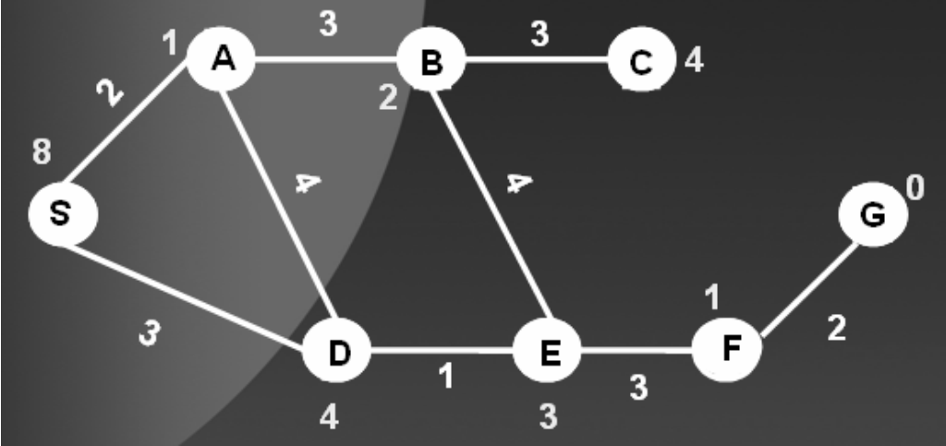
Q9. Run the MiniMax procedure on the given tree. The static evaluation scores for each leaf node are written under it. For example the static evaluation scores for the left most leaf node is 80.

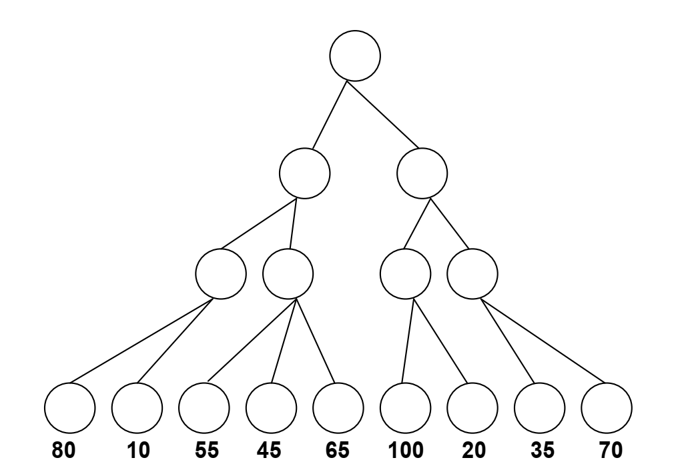
Q10 Discuss how Alpha Beta Pruning minimizes the number of static evaluations at the leaf nodes by pruning branches. Support your answer with small examples of a few trees.

Q11 Simulate the Minimax procedure with Alpha Beta Pruning algorithm on the following search tree.
